表 稳健性检验
 | 工具变量法 |  |  | 匹配法 |  | 处理效应模型 | 更换核心变量衡量方式 |  | 其他稳健性检验
 | (1) | (2) | (3) | (4) | (5) | (6) | (7) | (8) | (9) | (10) | (11)
 | GV | Invest | Invest | Invest | Invest | Invest | Invest | Invest | Invest | Invest | Invest
IV | 0.6773*** |  | 0.0551
 | (14.0537) |  | (0.6880)
GV_IV |  | 0.2946***
 |  | (2.5965)
GV |  |  | 0.2133*** | 0.2101*** | 0.2197*** | 0.2197*** | 0.4617*** |  | 0.2182*** | 0.2191*** | 0.2200***
 |  |  | (6.2757) | (6.0471) | (6.8780) | (6.7301) | (2.6355) |  | (6.6738) | (6.7840) | (6.8178)
GV_Num |  |  |  |  |  |  |  | 0.1110***
 |  |  |  |  |  |  |  | (6.0056)
IMR |  |  |  |  |  | 12.3444***
 |  |  |  |  |  | (4.8728)
GDP |  |  |  |  |  |  |  |  | -0.0003
 |  |  |  |  |  |  |  |  | (-0.1379)
STRU |  |  |  |  |  |  |  |  | 0.0693
 |  |  |  |  |  |  |  |  | (1.5983)
FD |  |  |  |  |  |  |  |  | -0.0045
 |  |  |  |  |  |  |  |  | (-0.9412)
VC |  |  |  |  |  |  |  |  |  |  | 0.0332**
 |  |  |  |  |  |  |  |  |  |  | (2.5541)
Cragg-Donald Wald F | 2023.909
Kleibergen-Paap rk LM | 54.401
SIZE | 0.0725*** | -0.0978*** | -0.0919*** | -0.0593*** | -0.0842*** | 1.8320*** | 1.0346*** | -0.0880*** | -0.0927*** | -0.0927*** | -0.0914***
 | (10.0394) | (-6.2603) | (-6.8137) | (-5.6238) | (-4.5460) | (4.7168) | (13.3743) | (-6.5363) | (-6.7351) | (-6.8398) | (-6.7291)
LEV | -0.1279*** | 0.0671 | 0.0567 | 0.0211 | 0.0220 | -4.2666*** | -0.8249*** | 0.0529 | 0.0611 | 0.0638 | 0.0544
 | (-6.9634) | (1.4536) | (1.3457) | (0.5451) | (0.2850) | (-4.8397) | (-2.6997) | (1.2517) | (1.4063) | (1.5118) | (1.2914)
ROE | -0.0290*** | 0.0412 | 0.0388 | 0.0124 | 0.0944* | -0.3689*** | 0.0817 | 0.0375 | 0.0301 | 0.0353 | 0.0393
 | (-4.6884) | (1.6288) | (1.5605) | (0.4555) | (1.8646) | (-4.2808) | (0.7404) | (1.5057) | (1.1231) | (1.4323) | (1.5801)
INDEP | 0.0564 | -0.1898* | -0.1852* | -0.0027*** | -0.0018 | 2.0142*** | 0.6457 | -0.1834* | -0.1682* | -0.1906* | -0.1856*
 | (1.4355) | (-1.9350) | (-1.9032) | (-2.6921) | (-0.9889) | (4.3777) | (1.2407) | (-1.8798) | (-1.6833) | (-1.9564) | (-1.9091)
TOP | -0.2040*** | 0.7061*** | 0.6895*** | 0.0062*** | 0.0088*** | -8.5426*** | -0.3105 | 0.6778*** | 0.6900*** | 0.6841*** | 0.6889***
 | (-5.3224) | (8.4356) | (8.3329) | (7.3928) | (6.6126) | (-4.5862) | (-0.8054) | (8.1734) | (8.2885) | (8.3146) | (8.3682)
BM | -0.0223** | 0.1360*** | 0.1342*** | 0.0849*** | 0.3044*** | -3.1904*** | -1.1916*** | 0.1342*** | 0.1375*** | 0.1299*** | 0.1328***
 | (-1.9985) | (4.5384) | (4.4946) | (2.7602) | (3.9771) | (-4.7104) | (-7.0916) | (4.4915) | (4.5273) | (4.3477) | (4.4431)
AGE | 0.0296 | -0.6143*** | -0.6119*** | -0.5989*** | -0.6382*** | -3.1310*** | 0.6241 | -0.6013*** | -0.6166*** | -0.6101*** | -0.5986***
 | (0.4872) | (-5.0629) | (-5.1064) | (-5.0923) | (-3.2215) | (-5.9638) | (0.9721) | (-5.0176) | (-5.1043) | (-5.0807) | (-5.0101)
SOE | -0.0166* | 0.0325* | 0.0311* | 0.0390* | 0.1478*** | -2.6585*** | -0.2855** | 0.0307* | 0.0318* | 0.0281 | 0.0302*
 | (-1.8528) | (1.7730) | (1.7267) | (1.9128) | (3.5365) | (-4.8218) | (-2.2435) | (1.6944) | (1.7504) | (1.5711) | (1.6778)
Constant | -1.5646*** | 4.0600*** | 3.9328*** | 3.2522*** | 3.6377*** | -47.2360*** | -22.7617*** | 3.8288*** | 3.9733*** | 3.9544*** | 3.8774***
 | (-6.7443) | (8.0861) | (8.5762) | (7.5728) | (4.9961) | (-4.5432) | (-9.1499) | (8.3460) | (8.4766) | (8.5822) | (8.4284)
Firm FE | YES | YES | YES | YES | YES | YES | YES | YES | YES | YES | YES
Year FE | YES | YES | YES | YES | YES | YES | YES | YES | YES | YES | YES
Observations | 26469 | 26469 | 26469 | 21274 | 26469 | 26469 | 24857 | 26469 | 26016 | 26226 | 26469
Adjusted R-squared | 0.8093 | 0.3177 | 0.3200 | 0.3442 | 0.4161 | 0.3217 | 0.4049 | 0.3193 | 0.3207 | 0.3200 | 0.3203
注：上表列（1）-（3）展示了工具变量回归的分析结果，第（1）列呈现了第一阶段的回归结果，第（2）列显示了第二阶段的回归结果，第（3）列将工具变量与GV同时纳入回归，以进一步检验工具变量的外生性；列（4）、（5）分别是在采用倾向得分匹配（PSM）和熵平衡匹配（EBM）法匹配样本的基础上进行估计的结果；列（7）、（8）分别是替换被解释变量和解释变量衡量方式后的估计结果；列（9）控制了地区经济发展水平（GDP）、产业结构状况（STRU）和金融市场环境（FD）的影响；列（10）剔除了发生过政府引导基金退出事件的企业样本；列（11）控制了风险投资（VC）的影响。

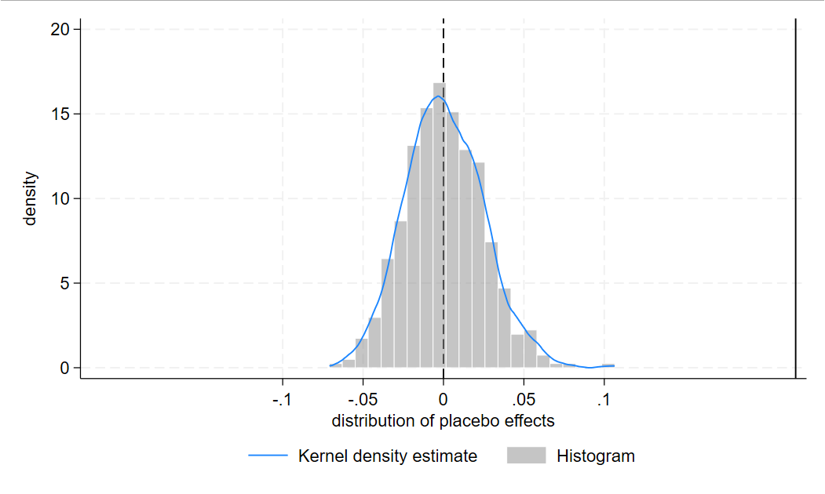
图 稳健性检验：安慰剂检验

表 机制检验
 | (1) | (2) | (3) | （4）
 | Visit | Analyst | Tran | ESG
GV | 0.1866*** | 0.2949*** | 0.5122*** | 0.1436***
 | (3.8939) | (6.0062) | (3.7924) | (2.6885)
SIZE | 0.2199*** | 0.7349*** | 0.1187* | 0.2846***
 | (12.9876) | (34.8941) | (1.8648) | (11.9397)
LEV | -0.2749*** | -0.5972*** | -2.5956*** | -0.8328***
 | (-5.0890) | (-8.7043) | (-11.1750) | (-10.4483)
ROE | 0.1922*** | 0.4255*** | 1.2725*** | -0.0218
 | (7.8057) | (14.0677) | (10.7917) | (-0.5810)
INDEP | -0.2170 | -0.2670* | -0.3534 | 0.5543***
 | (-1.6079) | (-1.7490) | (-0.6891) | (2.8642)
TOP | 0.1838* | 0.1877 | -0.0076 | -0.0763
 | (1.8300) | (1.5007) | (-0.0196) | (-0.5353)
BM | -0.5293*** | -1.8709*** | -0.1862 | -0.0401
 | (-13.8622) | (-39.5455) | (-1.2152) | (-0.8037)
AGE | -0.8435*** | -0.9057*** | 1.5418*** | -0.0603
 | (-4.8607) | (-4.8416) | (2.6476) | (-0.2871)
SOE | -0.0826** | -0.2748*** | 0.1537 | -0.0026
 | (-2.2340) | (-6.3880) | (1.1309) | (-0.0495)
Constant | -1.1690* | -10.9282*** | -0.5921 | -1.8952**
 | (-1.8345) | (-15.5890) | (-0.2582) | (-2.3859)
Observations | 26469 | 26469 | 17060 | 26101
Adjusted R-squared | 0.6341 | 0.7650 | 0.1040 | 0.5571
Firm FE | YES | YES | YES | YES
Year FE | YES | YES | YES | YES

表 异质性分析
 | 企业规模 |  | 是否战略性新兴产业企业 |  | 地区金融市场化水平
 | (1)小 | (2)大 | (3)属于 | (4)不属于 | (5)低 | (6)高
GV | 0.2804*** | 0.1869*** | 0.1889*** | 0.0877** | 0.2694*** | 0.1844***
 | (3.0223) | (6.1755) | (4.5083) | (2.4008) | (4.6561) | (4.9473)
SIZE | -0.1313*** | -0.0427** | -0.0465*** | -0.1037*** | -0.0939*** | -0.0896***
 | (-6.1238) | (-2.4149) | (-2.9574) | (-5.5542) | (-4.9445) | (-4.4293)
LEV | 0.1126* | -0.0197 | 0.0163 | 0.0686 | 0.1200* | 0.0100
 | (1.8932) | (-0.3410) | (0.2635) | (1.2758) | (1.7741) | (0.1781)
ROE | 0.0340 | 0.0035 | 0.0545** | 0.0282 | -0.0179 | 0.0843***
 | (0.8864) | (0.1392) | (1.9921) | (0.9347) | (-0.3937) | (3.4926)
INDEP | -0.0291 | -0.2850** | -0.2358 | -0.1189 | -0.0194 | -0.3345***
 | (-0.1773) | (-2.2412) | (-1.6057) | (-0.9439) | (-0.1254) | (-2.6240)
TOP | 0.8071*** | 0.5814*** | 0.6395*** | 0.7016*** | 0.5955*** | 0.7480***
 | (5.2003) | (5.5939) | (5.3506) | (6.6113) | (5.0070) | (5.8904)
BM | 0.2389*** | 0.0476 | 0.1292*** | 0.1078*** | 0.1053** | 0.1662***
 | (4.5321) | (1.2623) | (2.7593) | (2.8811) | (2.4430) | (3.8163)
AGE | -1.0144*** | -0.4017*** | -0.4708*** | -0.6164*** | -0.9584*** | -0.3504**
 | (-4.2860) | (-2.7360) | (-2.7796) | (-3.9036) | (-4.7145) | (-2.2815)
SOE | 0.0717** | 0.0059 | 0.0239 | 0.0298 | 0.0519* | 0.0063
 | (2.4931) | (0.2390) | (1.0353) | (1.1795) | (1.7699) | (0.2757)
Constant | 5.7427*** | 2.4112*** | 2.4939*** | 4.2380*** | 5.0082*** | 3.1263***
 | (6.5901) | (4.0145) | (3.8464) | (6.8876) | (6.3464) | (5.2692)
Observations | 13167 | 12898 | 9503 | 16928 | 11620 | 14266
Adjusted R-squared | 0.2879 | 0.3638 | 0.4052 | 0.2986 | 0.2874 | 0.3513
组间系数差异p值 | 0.0580 |  | 0.0520 |  | 0.0300
Firm FE | YES | YES | YES | YES | YES | YES
Year FE | YES | YES | YES | YES | YES | YES

表 经济后果检验
 | (1) | (2) | (3)
 | Crash | COD | RE
GV×Invest | -0.0213** | -0.0039** | -0.0019**
 | (-1.9794) | (-2.3239) | (-2.2016)
GV | -0.0312** | -0.0017 | 0.0017
 | (-2.3569) | (-1.2714) | (1.4626)
Invest | -0.0134*** | -0.0006** | -0.0009***
 | (-3.0359) | (-2.5142) | (-3.7415)
SIZE | -0.0340*** | -0.0010 | 0.0062***
 | (-4.8231) | (-1.5763) | (12.4442)
LEV | -0.0414* | 0.0508*** | -0.0016
 | (-1.6632) | (20.9384) | (-0.8225)
ROE | -0.0692*** | -0.0046*** | -0.0028***
 | (-4.3682) | (-4.2074) | (-2.9359)
INDEP | 0.1062* | 0.0078* | 0.0057
 | (1.6932) | (1.7776) | (1.5026)
TOP | 0.0894** | -0.0052 | -0.0115***
 | (2.1543) | (-1.5329) | (-3.6269)
BM | 0.2102*** | 0.0003 | -0.0126***
 | (12.2708) | (0.2528) | (-10.8614)
AGE | 0.0773 | 0.0046 | -0.0040
 | (1.3351) | (0.9663) | (-0.9556)
SOE | -0.0179 | -0.0029** | -0.0007
 | (-1.2045) | (-2.1688) | (-0.7067)
Constant | 0.4602** | -0.0057 | -0.0311*
 | (2.0083) | (-0.2963) | (-1.9551)
Observations | 25901 | 24432 | 26233
Adjusted R-squared | 0.0324 | 0.5878 | 0.6180
Firm FE | YES | YES | YES
Year FE | YES | YES | YES

